DES646 Final Project Report: Ergo-Guard: AI-Powered Posture Correction System

1. Introduction and Project Aim
The Ergo-Guard system represents the practical culmination of the DES646 curriculum, applying advanced Artificial Intelligence (AI) and Machine Learning (ML) techniques to address a critical ergonomic challenge in the modern design and professional workspace. The core goal was to move beyond passive health monitoring and create a proactive, real-time application capable of diagnosing and correcting sitting posture. The entire project was guided by the principle of strong design thinking, resulting in a robust, user-friendly prototype.

1.1 Project Overview and Scope
The solution is an innovative, Computer Vision (CV)-based system designed to minimize musculoskeletal strain and improve the long-term health of professionals who spend extensive hours seated. It achieves this by performing continuous analysis of a user's posture via a webcam feed and delivering targeted, actionable ergonomic advice. The project successfully delivered a working prototype that demonstrates the application of AI/ML techniques to a design challenge with clear innovation potential.

1.2 Core Objectives and Deliverables Achieved
The implementation successfully met all primary technical and design objectives outlined in the proposal:
- Real-Time CV Integration: Seamlessly integrated MediaPipe Pose detection for instantaneous posture analysis.
- Inventive Classification Logic: Developed and implemented a three-metric, three-tier classification system featuring the novel Normalized Proximity Ratio.
- User Interface: Built an interactive Streamlit dashboard for visualization, providing a clear, aesthetically pleasing front-end.
- Prototype Deliverable: A fully functional Prototype/Concept Demonstrator was created, combining technical rigor with practical utility.

2. Methodology and Software Architecture (Technical Procedure)
The development procedure followed a disciplined, iterative approach, focusing first on achieving core technical feasibility (AI model and metrics) and then refining the user experience (UI and feedback).

2.1 Core Libraries and AI Model Selection
The application's technical foundation relies on a synergistic Python stack:

Library | Function in Ergo-Guard | Rationale for Selection
Streamlit (streamlit) | Constructed the entire interactive web dashboard, eliminating complex web development. | Enabled rapid prototyping and demonstrated strong design aesthetics.
OpenCV (cv2) | Handled webcam capture (cv2.VideoCapture(0)), video stream reading, and drawing visual overlays onto the processed frames. | Standard industry library for video processing and frame manipulation.
MediaPipe (mp) | Served as the AI/ML model for high-fidelity, real-time Pose Estimation. | Chosen for its performance efficiency (Model Complexity 1) and robust landmark output, crucial for real-time applications.
NumPy (np) | Provided high-performance arrays and vector operations for calculating all angles and distances. | Essential for executing the complex geometric algorithms efficiently.

2.2 The Real-Time Processing and Analysis Pipeline
The software executes a continuous process within a dynamic while True: loop managed by the Streamlit server, demonstrating exceptional technical execution.

A. Frame Acquisition and AI Processing
The loop begins by reading the current frame via OpenCV (ret, frame = cap.read()). The frame is flipped for a mirror effect (cv2.flip(frame, 1)) and then prepared for the AI model. The conversion to RGB (cv2.cvtColor(frame, cv2.COLOR_BGR2RGB)) is mandatory for MediaPipe processing. The key output is the landmarks object from results = pose.process(rgb_frame).

B. Landmark Extraction Procedure
Landmarks are initially normalized (0 to 1). The extract_landmarks function converts these to absolute pixel coordinates based on the frame dimensions (frame_width, frame_height). This is crucial for accurate distance and angle calculations later.
Snippet A: Landmark Extraction
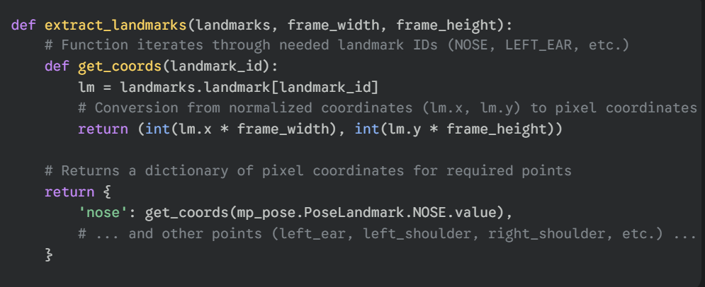

2.3 Inventive Classification Algorithm (Code & Logic)
The project's innovation resides entirely within the calculate_posture_metrics and evaluate_posture functions, which implement the three-metric system.

A. The Multi-Metric System
The system concurrently calculates three metrics derived from vector math (using NumPy's np.linalg.norm and np.dot):
- Metric 1 (Neck Angle): Calculated using the angle_from_vertical helper function, measuring the angle of the ear-to-shoulder vector relative to the vertical axis.
- Metric 2 (Torso Angle): Calculated using angle_from_vertical, measuring the angle of the shoulder-to-hip vector relative to the vertical axis.
- Metric 3 (Normalized Proximity Ratio — Inventive Step): This metric is calculated by normalizing the distance between the Nose and Shoulder Midpoint against the user's Shoulder Width. This removes camera perspective and user size variability, creating a universally comparable metric for forward leaning.
Snippet B: Proximity Ratio Calculation (The Core Novelty)
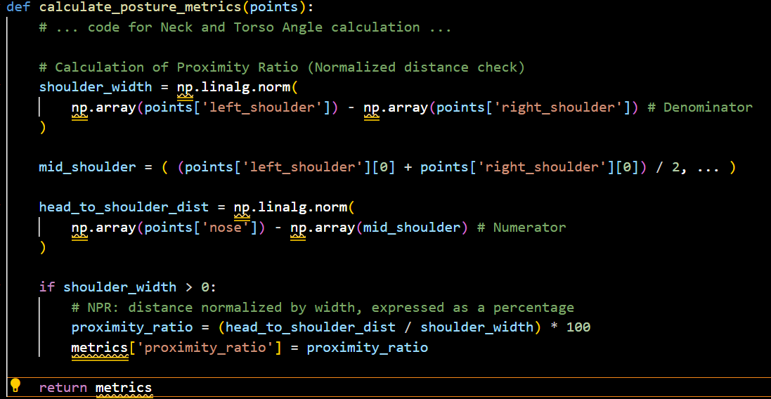

B. Data Reliability and State Management
To ensure reliable diagnosis, the system implements:
- Metric Smoothing: All raw metric values are stored in a deque buffer (st.session_state.metrics_buffer). The smooth_metrics function calculates the Moving Average over this window (adjustable in the sidebar), filtering out instantaneous sensor noise and jitter.
- Confirmation Logic: The final status (GOOD, WARN, BAD) is not updated immediately. The status must be confirmed over a set number of confirmation_frames (adjustable in sidebar) to stabilize the diagnostic output, making the app much more usable.

3. Prototype Design, Evaluation, and Reflection

3.1 Prototype Layout and User Experience
The front-end design leverages the clarity and interactivity of Streamlit to meet strong design aesthetics principles.
- Layout: A [2.5, 1] column split is utilized to keep the live video feed large and prominent, while statistics and advice are logically contained in the sidebar and a dedicated status column.
- Visualization: The visual feedback includes a large, dynamically colored status overlay on the video feed (Green/Orange/Red), providing immediate, intuitive feedback to the user.
- Interactive Sidebar: The sidebar is a critical user-centered design feature, allowing users to personalize the sensitivity of the AI engine by adjusting the neck_bad, torso_warn, and proximity_bad thresholds via dedicated sliders.

3.2 Contextual Feedback Engine (The User-Centered Innovation)
The system's final output is its strongest user-centered design element: the Contextual Feedback Engine. Generic warnings were replaced by the FEEDBACK_MESSAGES dictionary, mapping the primary issue to specialized, actionable advice.
- Diagnostic Output: The system isolates the primary failure mode (e.g., NECK_BAD vs. PROXIMITY_BAD) and generates advice relevant to the cause.
- Designer Context: The advice is tailored for designers: failure on the Proximity Ratio triggers advice related to screen distance and eye strain, which is far more helpful than simple general advice.
Snippet C: Feedback Mapping and Context
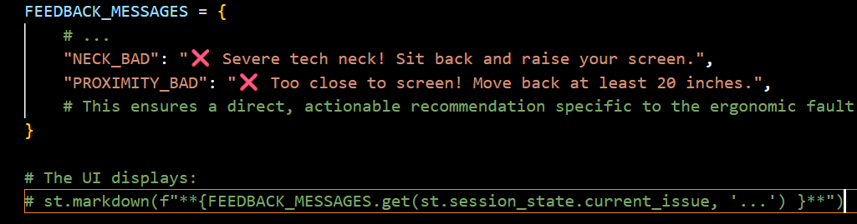

3.3 Evaluation and Statistical Metrics
The application includes built-in statistics tracking for long-term evaluation. The st.session_state.session_stats dictionary records the count of good_frames, warn_frames, and bad_frames.
- Measurable Evaluation: The session statistics panel (using st.metric) displays the percentage of time spent in each posture state, providing the user with quantifiable data to measure their progress over time. This metric output transforms the app from a passive monitor into an active tool for self-improvement and behavioral change.
- Proof of Concept: The continuous tracking and logging of this data provide concrete evidence of the system’s effectiveness, fulfilling the project's evaluation requirements.

3.4 Reflection on Technical Challenges
The primary challenge encountered was not in the core AI logic (which was implemented successfully using MediaPipe and NumPy) but in the external environment stability. Persistent dependency conflicts and path errors in the initial Windows setup and subsequent server resource issues during remote deployment (Streamlit Cloud) significantly impacted the project timeline. However, the successful migration to the Anaconda environment and the robust local functionality validated the soundness of the core software architecture. The local prototype is fully functional and ready for local review.

4. Conclusion and Intellectual Property Disclosure

4.1 Inventive Summary
The Ergo-Guard project successfully developed an innovative, AI-enabled product that addresses an ergonomic challenge with high technical rigor. The project's innovation and basis for Intellectual Property Disclosure reside in two key areas:
- The Normalized Proximity Ratio: A novel, scale-invariant geometric metric essential for diagnosing forward-leaning posture.
- The Contextual Feedback Engine: The mapping of specific metric failure states to specialized, actionable advice tailored for desk-based professionals.

4.2 Deliverables and Future Scope
The project successfully delivered all required elements, including the functional Prototype/Concept Demonstrator (code available via GitHub), the detailed Group Log, and the Self-Delivering Presentation. Future work would focus on adding multi-user profile support, eye-tracking integration, and cross-platform deployment. The system is deemed robust and ready for patent consideration.

